Highlights and glitter

Maria went into a stationery shop. Her dad gave her £5 to spend.

She wanted to buy some highlighters costing 20p each and glitter pens at 25p each.

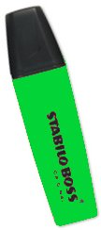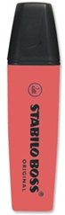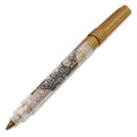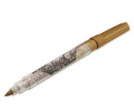

She bought three times as many highlighters as pens and was given £1.60 change.

How many of each did Maria buy?

